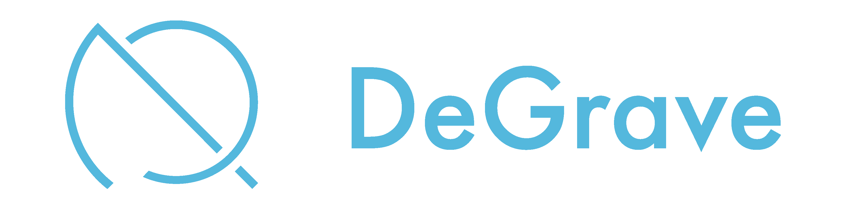
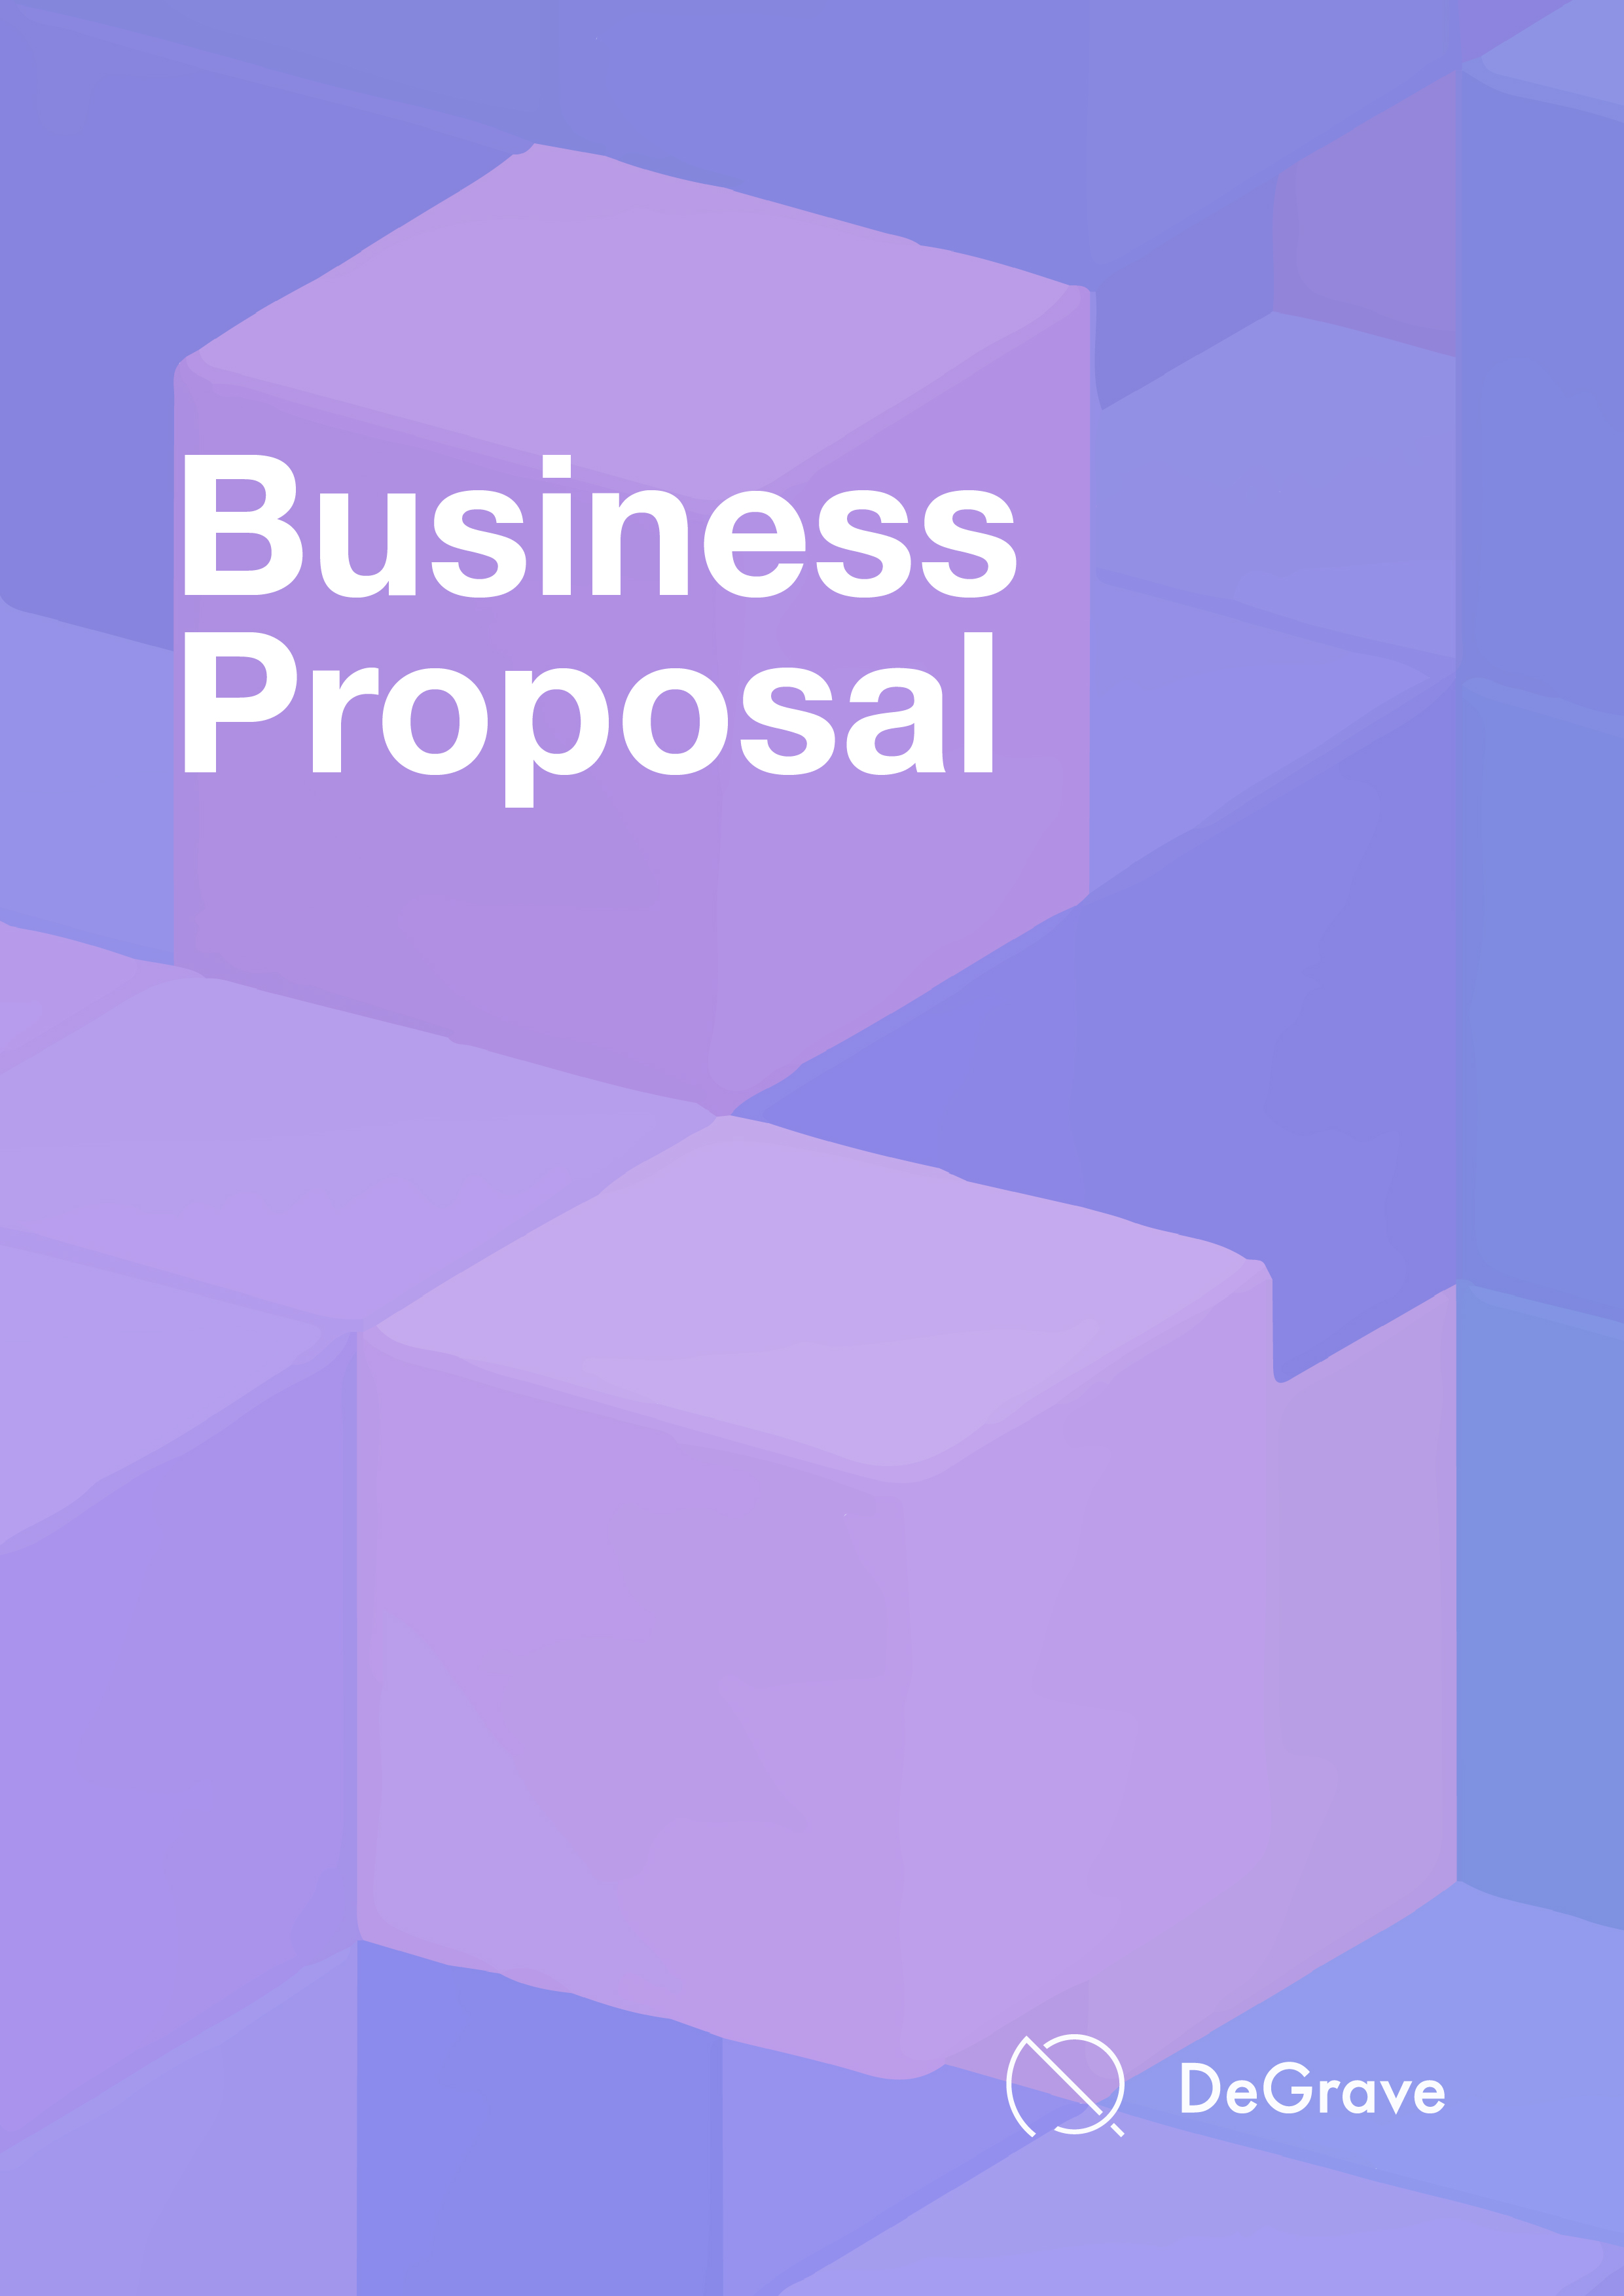
The whitepaper is considered to be a working document and will be updated as and when required in line with the latest developments.

White
Paper


Executive Summary
The Problems
The Solutions
Why are we Different?
DeGrave.io Platform
Business Model
Decentralized Business Model and Governance
Tokenomics
Token Utility
Disclaimer
Roadmap
Our Team

3
4
5-6
7-8
9-11
12
13
14
15-17
18
19
20

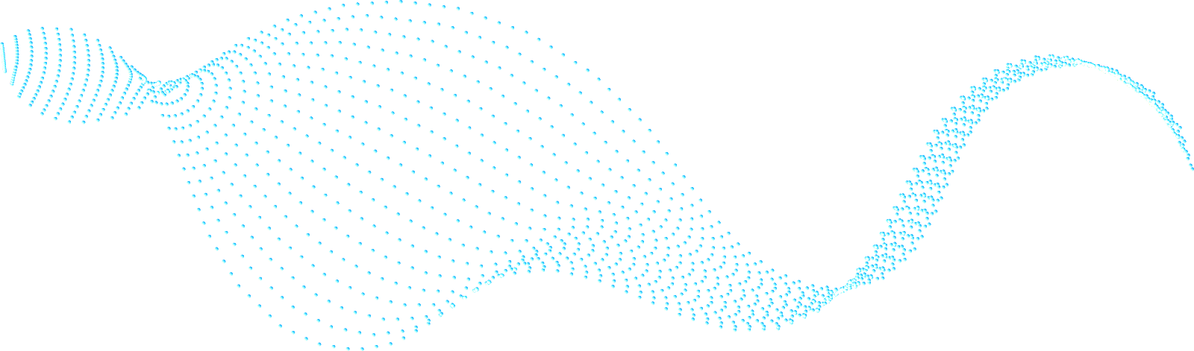
Executive Summary
Founded in 2021, DeGrave.io aims to provide a decentralized blockchain graveyard by creating NFT graves to have an excellent experience of online memorializing.

DeGrave.io is aiming to create a multi-chain ancestor memorializing platform that will be fulfilled by incorporating Binance Smart Chain and other compatible blockchains. Initially, DeGrave.io has been carefully designed and engineered for its users to create NFT Graves based on the Binance Smart Chain blockchain for memorial and preserve memories.

Our service is supported by the Deathcoin ($DTC), the native cryptocurrency of the platform. Deathcoin is used primarily as a reward system on DeGrave.io when creating NFT graves, purchasing digital offerings and making cryptocurrencies donations. In order to establish Deathcoin as a valuable cryptocurrency, we will build a decentralized and community-driven interpersonal network, and promote users to use Deathcoin as a trading medium for goods, services and knowledge in real life, and eventually will be listed on cryptocurrency exchanges, allowing users to exchange Deathcoin for other legal currencies.

DeGrave.io’s mission is to provide an easily accessible ancestors memorializing platform for users despite time and distance constraints. To achieve this, we have created a chain-based NFT graveyard featuring a well-designed comprehensive online memorializing system.

We have built our vision of the DeGrave.io ecosystem aligned with the agnostic approach of the industry leaders within the blockchain ecosystem. Incorporating the fundamentals of the decentralized technology with providing interoperability, fast execution and layer 2 solutions within its development roadmaps.
The Problem
Online worshipping requires attention to detail. The latest technology such as NFTs, cryptocurrency and blockchain technology has failed to be adopted across this ever-growing industry. Other problems are outlined below:

Ancestors’ Families
- Not allowed to create a valued online grave like the traditional ones
- Cannot easily collate social media information of the deceased
- Lack of online platforms to host a user-friendly memorializing experience
- No cryptocurrency payment options for receiving offerings and donations

Ancestors’ Worshippers
- Outdated memorializing processes with time and space constraints
- Lack of trust and transparency memorializing system
- Limited payment option for offerings and donations available
- Cannot preserve unique memories with the deceased

Why these problems do exist?
- No sustainable and stable online memorial platform
- Lack of real value in the online grave and memorializing system
- Platforms are not adapting to new trends of blockchain
- Do not support cryptocurrency payments
- No access to create NFT Grave

A successful online ancestor worshipping platform should empower the value of the grave and the whole worshipping process, enhance the connection between the deceased and the worshippers, whilst ensuring they can make more relevant the impact of user reputation and trustworthy reviews.
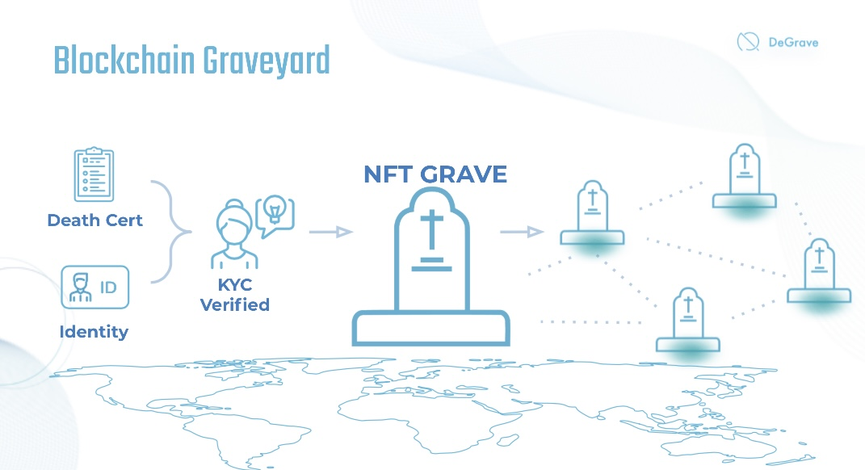
The Solution
DeGrave.io is a blockchain graveyard with ancestors memorializing platform where users can create NFT grave, collate deceases’ social media info, purchase digital offerings and make donations. A user just needs to upload their digital information such as pictures and personal information, select the blockchain network, and other settings of the NFT, to create a pre-NFT monument. The NFT monument will be created and launched only when the digital signature is generated by verified ID and death cert. Extra social media content can also be created as NFTs’ memorable collection to trade on the platform to preserve the unique memories between the ancestors and worshippers.

We will be initially providing access to the Binance Smart Chain then forming a cross-chain solution to Ethereum Blockchain. Users will be provided with the same service regardless of the chain they choose to utilize. With future scope to allow access to all chains capable of offering NFT graves and other digitized goods.

Moving forward the previously-identified problems for users and worshippers can be addressed below:

DeGrave.io Users
- Create a valued online grave with a perfect memorializing system supported
- Zero fees for creating NFT grave
- Define scarcity option of NFT grave with KYC and death cert verified
- Customized and extended preview options for your NFT Grave
- Receive cryptocurrencies donations through the DeGrave.io platform
- Purchase digital offerings for the ancestors
- Display records of worshippers and offerings received
- Create your own NFT memory collections in any way with support for all file types including 2D and 3D media, audio, video, and more
- Store private files that only can be unlocked in full for the current owner or appointed users
- Can leverage tokenized rewards
- Can leverage blockchain smart contracts to form the trusted layers of the Deathcoin.io platform

DeGrave.io Worshippers
- Memorize ancestors despite time and space constraints
- Can trust 100% of NFT graves is belong to the deceased
- Can preserve unique memory collections through offerings and donations
- Multiple currency payment options
- Can leverage tokenized rewards
- Can leverage blockchain smart contracts to form the trusted layers of the Dealthcoin.io platform

Why are we Different?
Blockchain Graveyard
DeGrave.io creates a non-fungible physical object, GRAVE. And we build an ecosystem around it which holds value. With the distinct existence of NFT digital signatures on the blockchain, we can create the unique value of the eternal manifestation of an NFT grave to commemorate the deceased. With more and more graves being created on the blockchain, we will create an intangible, environmentally friendly and space-saving Blockchain Graveyard.

Users Verification
DeGrave.io verifies the identity and contributions of users with Blue Check on our ecosystem. Accounts with Blue Check means it is a notable and authentic account, can protect worshippers from fraudulent activity. To become verified, a user must first apply within the DeGrave.io platform, from there it will be verified with ID checking using KYC, and death cert checking for launching NFT grave. In the future, Deathcoin.io will configure an AI capability to perform the verification process.

Ancestors Worshipping System
DeGrave.io allows worshippers to purchase digital offerings and make donations to the deceases and their families using Deathcoin. The number of worshippers, offerings and donations received will be displayed alongside the monumental page. Social media links, media albums will be allowed to review by users while private files can also be unlocked by designated users of the deceased.

NFT Memory Collections
The rise in the NFT market has created a catalyst for major blockchain protocols to deploy NFTs within their offerings. DeGrave.io resell vertical will allow deceased with NFT memory collections on multiple blockchains, a location in which they can allow worshippers to purchase those memories in one place. Dealthcoin.io intends to bridge the gap of user experience where others lack, providing an all-in-one solution on a multi-chain memorializing platform. *NFT memory collections are not able to be swapped from blockchain to blockchain at this stage.
Reward System
DeGrave.io’s token model will give users token rewards. Users will be awarded Deathcoin daily when they list verified NFT graves on DeGrave.io for memorializing. Ancestors' worshippers will be given the opportunity to earn rewards for performing specific tasks such as referring friends, helping drive forward the adoption of the memorialize system to new users. There will also be staking rewards for Deathcoin holders. (Please refer to the Token Economics below)

Multi Chain Support
DeGrave.io maintains an open approach to all blockchains and compatibility. We are not limiting our services to a specific blockchain and we intend to provide our users and the entire blockchain ecosystem with a cross-compatible e-marketplace. Initially focused on Etereum and Binance Smart Chain with research undergoing into Crypto.com Chain, Polkadot Chain and others upon our users’ request.

Users First Approach
DeGrave.io’s initial users will be at the forefront of the adoption of the platform, their say on how the product and platform develops is essential, see the Token Economics for more details.

Cross-Platform Perpetual Royalties
DeGrave.io will initiate a research and development strategy to implement the ability for users to adopt cross-platform perpetual royalties.
DeGrave.io Platform
Understanding the DeGrave.io Ecosystem
The DeGrave.io ecosystem is configured to meet the requirement in an innovative, robust and user-friendly manner. We are creating a blockchain ancestors memorialize system where users can create NFT graves, digitalized memory collections and collate social media’s information whilst allowing information to be transferred among stakeholders securely. Ancestors’ worshippers can use Deathcoin to purchase offerings and make donations. The DeGrave.io advertising system allows users on our platform to promote the NFT grave to the top of the web and allows search engine optimization to be maximized. Both DeGrave.io users and ancestors’ worshippers can benefit from the multiple rewards related to the Deathcoin reward system.

Multi-Platform Capability
DeGrave.io initially creates a desktop platform followed by an application as displayed in the Roadmap. It is available across all web browsers alongside iOS and Android. The desktop platform is built on various pillars to maximize technological capability. We anticipate that our desktop platform and application will be the bridges for users
not familiar with the blockchain space, providing the accessibility and functionality of
the blockchain protocols in a user friendly and inviting way.

Account Module
DeGrave.io’s users have the ability to provide personal profile details, pre-create NFT Grave, designate another DeGrave.io’s user as pre-NFT Grave ownership, the redemption of NFT grave through death cert and report illegitimate content. All NFT-Grave launchers must register DeGrave.io accounts with ID verification through KYC technology. Our system has an account module that provides the support of email and password authentication for users together with other federated authentication providers. This account module is user friendly and provides flexibility for users to personalize their accounts.
Multi-Chain Support
DeGrave.io has the goal to become a multi-chain ancestors memorializing platform. We will initially focus on Binance Smart Chain with development continuing onto the Ethereum Blockchain and gradually expand our offerings to other smart-contract-enabled blockchains at a later stage. NFTs based on different blockchains are separated and independent. Users will be able to switch between the chains easily on the DeGrave.io user interface however it is not possible to move a minted NFT from one chain to another. An NFT grave creator or owner would have the right to submit their content on multiple blockchains at the time of minting. Initially, Deathcoin will be a BEP20 token on the Binance Smart Chain. The strategic approach of DeGrave.io, as we expand, we do intend to create a bridge between target blockchains such as Ethereum Blockchain to allow our users ease of access to all functionally with the platform.

NFT Specification
DeGrave.io’s NFT graves conform to the ERC1155 specification. Our NFTs work with all external systems that support the ERC1155 standard. DeGrave.io’s NFT metadata makes use of the same format and rules specified by all leading NFT compatible platforms. Each of our NFT’s metadata contains a signature signed by DeGrave.io’s system’s private key. This means that a user can always identify whether or not an NFT is minted by the DeGrave.io system.

Content Storage
The digital content file is the core part of DeGrave.io NFT Grave and the memorializing system. However, due to the high cost of blockchain storage, it is inefficient to store such a large file on a chain, meaning all digital content files will be stored on the IPFS network, which is a decentralized and mature storage protocol. IPFS identifies files based on their hashes. DeGrave.io stores a digital content’s hash into the corresponding NFTs metadata. The metadata itself is stored as a JSON file on IPFS, and the hash of the JSON metadata file is stored on chain as the token URI and hence the integrity of the NFT as a whole is guaranteed. Because a file on IPFS exists only as long as at least one node pins it, our system maintains an IPFS cluster to pin its files. In the future, we may store files on one of the external IPFS service providers instead of or in addition to our IPFS cluster.

Unique Guaranteed
DeGrave.io ensures all users are protected by the hash of an NFTs digital content file which is stored on the blockchain. Since every NGT Grave and memory collection is required for authentication (ID and death cert are required) during the creation process, our system has the capability to ensure its uniqueness. It can prevent a repeat creation. Our digitized system also provides the user with the option to “Report”, a function for users to report fake or duplicated grave or content that is in violation of DeGrave.io’s terms and services. Once reviewed any content or grave that is proven to be invalid, they will be permanently deleted from DeGrave.io’s platform.

User Type
Creators
DeGrave.io provides the capability for everyone to pre-create NFT Grave on our platform, create their own NFT memory collection and have the authority to preserve them for future worshippers to purchase with Deathcoin on our platform. The user will keep in mind to designated a DeGrave.io user for the ownership of the NFT grave and verify his death cert when he passes away. The designated user will have the right to manage the NFT grave and receive offerings and donations from future worshippers.

Deceased’s Family
Deceased’s family (Designated Users) has a simplified process of listing NFT graves, processing offerings or donations from the worshippers through smart contracts. Our platform focuses primarily on the listing of NFT graves and provides a unique option for the deceased's family to promote the NFT grave on top of the DeGrave.io web.

Ancestors Worshippers
Worshippers experience a simple user interface to ensure they are engaging with a user-friendly worshipping platform. The worshippers are able to use the Search Bar to find the corresponding NFT grave of specific deceased, they can also configure their account with social media links for allowing automated NFT grave suggestions of related ancestors they may know with on their homepage. With Deathcoin, worshippers can purchase digital offerings and make donations to give support and sympathy with the deceased's family.
Business Model
Digital Sacrificial Offerings
Digital offerings will be allowed to purchase on the DeGrave.io platform with cryptocurrencies. The offerings purchased numbers will be listed on the NFT Grave page of the ancestors. Deathcoin will serve as main means of payment within the system, but we will also accept other types of cryptocurrencies.

Donations Transactions
The DeGrave.io allows users to offer monetary donations to deceased families on our platform with cryptocurrencies, allowing us to generate commissions directly through both the worshipper and the family. Our commission fees range will be set as 5% per donation transaction.

NFT Grave Promotion
The DeGrave.io allows users to advertise their NFT Grave on top of the web and allow search engine optimization to be maximized.

Integration Fees
Integration fee is charged when cryptocurrency foundation and/or project who want their cryptocurrency to be listed as a form of payment on DeGrave.io.

Advertising
Deathcoin.io offers direct marketing opportunities to sellers and strategic partners. The cost for this service will be calculated when factors such as ad placement, size and type are considered.
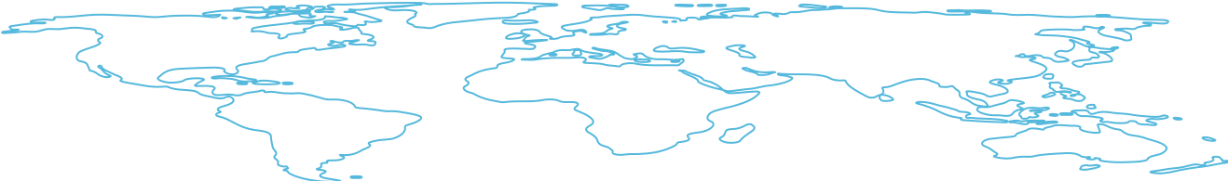
Decentralized Business Model and Governance
DeGrave.io’s vision is to migrate over to a fully decentralized business model which is governed by the Deathcoin token holders. Governing areas include; token supply, incentive, rewards, community developments and more. This will be introduced at a later stage when the platform is fully operational with relevant technologies implemented.
DeGrave.io’s blockchain software development is potentially be made modifiable through the voting rights granted by the Deathcoin token holders. All holders are given voting rights on selected governance issues relating to our platform. For example, a certain percentage of every digitized goods sold could go into a community fund, with Deathcoin token holders are given the right to vote on the use of funds. The percentage of arranging the sale revenue of digitized goods into a community fund and the right of voting on how to use the funds
This is not limited and it is possible to give the rights to the DeGrave.io community for voting on more fundamental parameters such as fees charged for users and worshippers.
It is essential for DeGrave.io to use this method, the key advantage of decentralized governance in our context is that it increases customer engagement, satisfaction and loyalty. It will provide Deathcoin token holders with the right to vote and provide a purpose to the future of DeGrave.io, aiming to increase the token value whilst building a strong community.
Tokenomics
Overview
The Deathcoin token ($DTC) will ensure a fully decentralized model of governance. All stakeholders will have a stake in guiding the protocol’s development process by voting mechanisms. Therefore, the token is a governance token for the ecosystem.
It is crucial that token holders, that have been given the ability to vote on governance, are bonded to the success of the protocol in some way. This model is a well understood and successful way to ensure an alignment between token holders and the best interests of the protocol.
Also, Deathcoin token plays a vital role in the core business model of DeGrave.io by providing a fundamental backbone to the platform. The Deathcoin token provides additional benefits and enhances user engagement whilst being able to adopt the cryptocurrency for business activity.
The Deathcoin token will be governed by smart contracts pivoting the platform to Web 3.0, maintaining transparency throughout the processes within the platform. We will also explore the token mechanics added by other successful protocols, to see if their incentive mechanisms can supplement the NIIFI token utility. Those mechanics can be brought to the token holders as further recommendations for voting.
Token Name | Deathcoin
Ticker | DTC
Blockchain | Binance Smart Chain
Token Type | BEP-20
Token Supply | 888,888,888

Token Utility
Deathcoin will be created on a public ledger and will serve the primary functions below:
Token Holders
- Governance: Allow validated users to influence protocols decisions
- Staking Rewards: Stake Deathcoin to get rewards

NFT Grave Owners
- Receive Deathcoin reward daily when listing NFT Grave
- Reduced commission fees when receiving donations

Ancestors Worshippers
- Receive discounts on purchasing digital offerings and NFT memory collections
- Reduced commission fees when making donations

Token Details
Token Allocation

DeGrave.io will burn at least 30% of Deathcoin total supply. The burning will be gradually implemented through the progressive destruction of Deathcoin tokens.
This burning operation is designed to pursue the following aims:
- To bring the Deathcoin in line with the deflationary philosophy characterizing the crypto space
- To accentuate the scarcity effect around the tokens needed to access use the ecosystem
- To protect token holders from the purely speculative variations of the crypto market
Category | Supply% | Tokens | Price | Notes
Private Sale including Seed | 15% | 133.3M | 0.0045 | Private Investors including VCs
Public Sale | 5% | 44M | TBC | Public
Development Pool | 10% | 88M | N/A | Core development and growth
Advisory & Marketing | 10% | 88M | N/A | Advisory fees & product marketing
Burn Pool | 30% | 266M | N/A | Tokens for burning in the future
Team | 12.5% | 111M | N/A | Allocation for team and future team
Future Liquidity | 1% | 8.8M | N/A | Token Liquidity
Ecosystem Rewards Pool | 16.5% | 146M | N/A | Pool used to fund the reward system

Token Vesting and Emission Details

NFT Grave Listing Rewards
Listed NFT grave will be rewarded Deathcoin on a descending trend, DeGrave.io will provide a total of 146,666,666 Deathcoin tokens as listing rewards, the reward system will be terminated once all tokens are rewarded. Detail of the staking reward system are shown below:

Number of Blockchain NFT Graves | Token Rewards | Expected Time Required
First 500 NFT Graves | 5 $DTC / Day | 3 Months
1,000 NFT Graves | 2.5 $DTC / Day | 6 Months
5,000 NFT Graves | 1 $DTC / Day | 9 Months
10,000 NFT Graves | 0.5 $DTC / Day | One Year
30,000 NFT Graves Onwards | 0.23 $DTC / Day | Two Years

Category | Vesting% | Tokens | Emission Start | Emissions | Token Emissions p/m
Seed Sale | 16.6% | 50M | TGE | 6 | 8.3M
Private Sale | 20% | 83.3M | TGE | 5 | 16.66M
Public Sale | N/A | 44M | TGE | N/A | 32.12M
Ecosystem Rewards Pool | 4.16% | 146M | TGE + 3 months | 24 | 6.08M
Development Pool | 6.67% | 88M | TGE + 3 months | 15 | 5.87M
Advisory and Marketing | 3.57% | 88M | TGE | 28 | 3.14M
Burn Pool + Liquidity | 4.17% | 274.8M | TGE + 6 months | 24 | 11.45M
Team | 8.3% | 111M | TGE + 12 months | 12 | 9.25M

Disclaimer

The amounts in the table above are estimates and may slightly vary over time. It is important to note that the reserve is locked and that after it’s unlocking it will be used to finance projects related to the ecosystem. The use of these tokens will be subject to a vote of the Deathcoin holders. The percentage distribution of the number of tokens per sub-category of the seed and private sale is not fixed and can be modified to meet the demand within the maximum amount of the category.


Roadmap

2021 Q2
- Conception of the idea
- Design Tokenomics
- Design Go-To-Market Strategy

2021 Q3
- Proving concept viability
- Partners / Marketing Outreach
- Team Building
- Pitch Deck Completion
- Website Completion

2021 Q4
- Public Launch
- Seed Round Token Sale
- Smart Contract Deployment
- Marketing Campaign
- NFT Grave Listing Rewards Start

2022 Q1
- Private + Public Token Sale
- BSC Integration
- Token Generation Event
- Team Expansion

Future Plans
- R&D of IOS and Android Application
- Multi-cryptocurrencies payment method
- Additional Deathcoin Use Cases
Our Team
Co-Founder & CEO – Raphael Lau
With a strong business development background and a key focus on new trends in the market, Raphael co-founded DeGrave.io. He believes what he is doing for blockchain technology currently will revolutionize and redefine the traditional business

Co-Founder & COO – Wynne Poon
Wynne is detail-oriented multi-tasker who thrives in fast-paced environments. She co-founded DeGrave.io, steps into the blockchain industry which is going to be the global trend.

Co-Founder & COO – Vincent Wong
A blockchain technology enthusiast and software engineer with experience in leading and managing multiple startups R&D team development. Currently, DeGrave.io development team led.

CCO – Curtis AuYeung
Curtis is skilled in the production of high-quality design concepts and strategies with the ability to utilize different software for the successful creation of new ideas and concepts.

CIO – Benedict Casino
A seasoned software engineer equipped with prior knowledge and key involvements in programming and Machine Learning. Pursuing development and growth in the blockchain technology environment.

CFO – Kenny Wong
Expert at financial analysis, forecasting and excel modelling whilst minimizing business risk. Businesses under Kenny’s control are equipped with the tools necessary to meet aggressive sales and growth plans.

Our Advisors

Partnerships

